LAB – The Period of a Spring

Your Name:

Purpose: Write one or two sentences explaining what you are trying to figure out in this lab. Make sure your purpose includes all of your independent and dependent variables
Using mass, spring constant, and amplitude, we are going to determine how it affects the period of a spring.

Hypothesis: Predict what the relationship will be between each of your independent variables and your dependent variable (i.e. directly proportional, inversely proportional, no effect). Make sure to explain why you think each of these relationships will hold.

Hypothesis #1: Mass and Period of a spring are proportional.

Explanation: I think that because the more mass on the spring, then the greater the period would be.

Hypothesis #2: Spring constant and Period of a spring are inversely proportional.

Explanation: I think that because the tighter the spring, then the higher the spring constant, while a lower spring constant would have a greater stretch, so the periods will be different.

Hypothesis #3: Amplitude and period of a spring are directly proportional.

Explanation: The greater the amplitude, the period will be affected.

Procedure: Make a brief list of the steps you follow in the lab.
- Explain how, specifically, you will be measuring the dependent variable
- Explain how many values of each independent variable there will be and how many trials you will perform on each value.
- Make a list of all three experiments that you will perform

- We will measure the period of a spring by letting it oscillate 10 times and measuring how long it takes. We will repeat this 3 times.
- We will change each independent variable 5 times.
- There will be three experiments: changing mass and measuring period, changing amplitude, and measuring period, and changing spring constant and measuring period.

Data: Show all data tables for each of your experiments.
- Be sure that each data table has a descriptive title.
- Be sure that each data table lists the variables you are holding constant & their values
- Make sure all units are labeled.
(It is OK to label the units in the table headings instead of in each individual cell)

HINTS:
- When testing spring constant, use 150 grams at an amplitude of 5 cm
- When testing amplitude use spring #2. Pick a mass that gets an appropriate amount of extension out of the spring without going overboard.
- When testing mass, make sure to think ahead about which spring and weights to use so that you don’t over-stretch the spring.

Experiment #1. Title: Changing Spring Constant and measuring Period
Constant Variables: Amplitude (5 cm) Mass (150g)
Spring # and values | Time of 10 oscillations |  |  |  | Period (sec) Average/10
 | Trial #1 | Trial #2 | Trial #3 | Average
1B: 28.1 N/m | 4.63s | 4.81s | 4.94s | 4.793s | 0.47933s
2B: 20.0 N/m | 5.38s | 5.25s | 5.44s | 5.356s | 0.53566s
3B: 14.0 N/m | 7.19s | 7.31s | 7.00s | 7.166 | 0.71666s
4B: 6.8 N/m | 10.06s | 9.63s | 9.81s | 9.83s | 0.98333s
5B: 2.4 N/m | 15.38s | 15.06 | 15.19 | 15.2s | 1.521ss
Picture of graph:
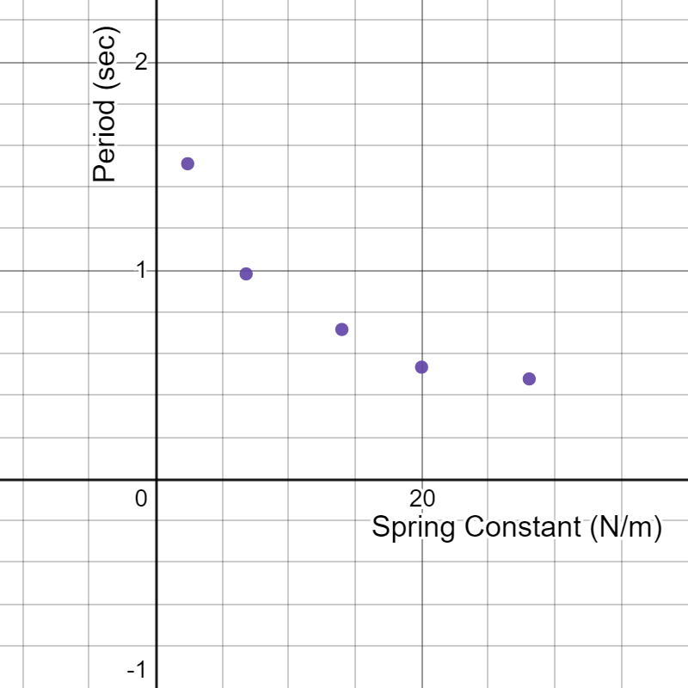
Link to graph: https://www.desmos.com/calculator/6ospesbs1z

Experiment #2. Title: Changing the Mass and finding the Period
Constant Variables: Amplitude (5cm) and Spring Constant (20.9 N/m)
Mass (g) | Time of 10 oscillations |  |  |  | Period (sec) Average/10
 | Trial #1 | Trial #2 | Trial #3 | Average
70 g | 5.50s | 5.50s | 5.25s | 5.42s | 0.542s
100g | 6.50s | 6.06s | 6.19s | 6.17s | 0.617s
120g | 6.19s | 6.38s | 6.44s | 6.34s | 0.617s
150g | 6.88s | 7.06s | 7.19s | 7.04s | 0.704s
170g | 7.69s | 7.69s | 7.69s | 7.69s | 0.769s
Picture of graph:
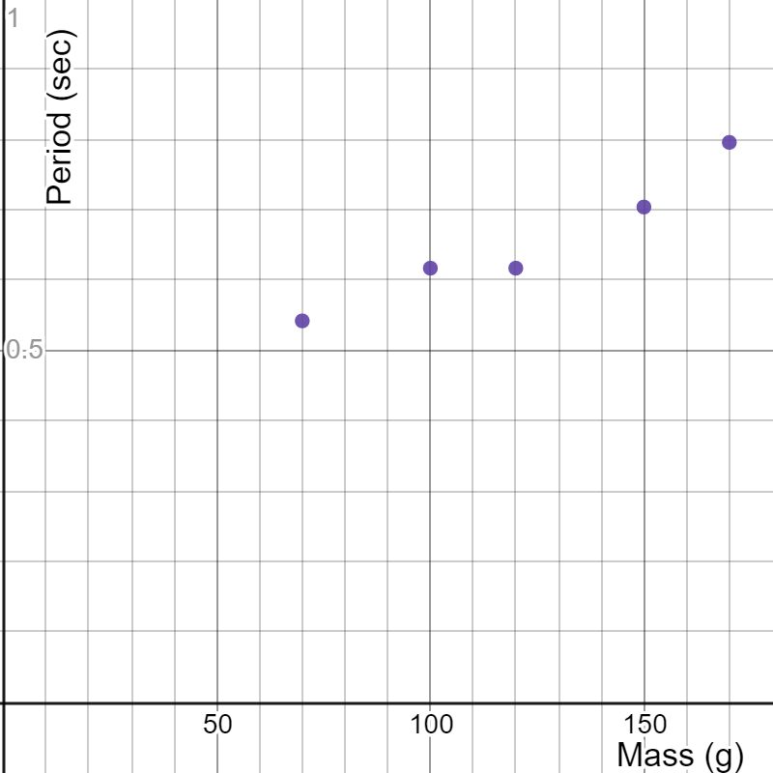
Link to graph: https://www.desmos.com/calculator/crxadkdj06

Experiment #3. Title: Changing Amplitude measuring period
Constant Variables: Mass (250g), Spring Constant
Amplitude  (cm) | Time of 10 oscillations (sec) |  |  |  | Period (sec) Average/10
 | Trial #1 | Trial #2 | Trial #3 | Average
14 | 8.19 | 8.25 | 8.31 | 8.25 | 0.825
9 | 7.88 | 7.38 | 6.5 | 7.25 | 0.725
16 | 7.63 | 7.38 | 7.56 | 7.52 | 0.752
12 | 8.19 | 7.44 | 7.50 | 7.71 | 0.771
19 | 7.19 | 7.38 | 7.63 | 7.4 | 0.74
Picture of graph:
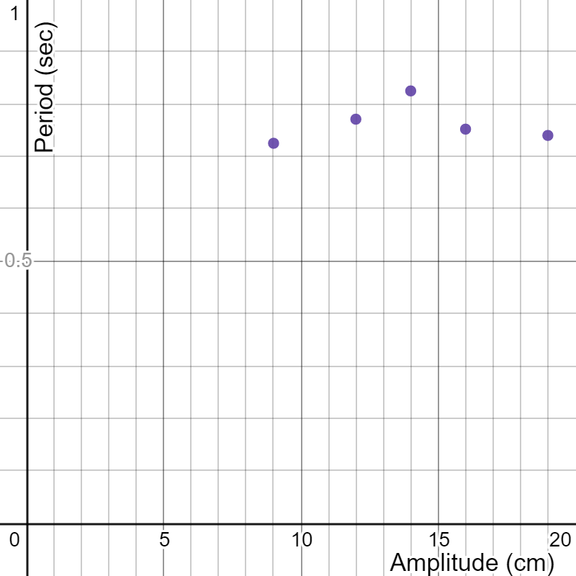
Link to graph: https://www.desmos.com/calculator/wfc8ciuesz

Results: Explain what your data show. What was the relationship between each of your independent variables and your dependent variable (i.e. directly proportional, inversely proportional, no effect, unclear)? Did they match your hypothesis?
- Spring Constant and period are inversely proportional
  - I was correct with my hypothesis.
- Mass and Period are directly proportional
  - I was correct with my hypothesis.
- Amplitude and Period have no effect on each other.
  - I was incorrect with my hypothesis because I thought that they would affect each other when they didn’t.

Conclusion and Discussion: Answer the following questions in paragraph form.
- What was the purpose of the lab?
- How did you go about accomplishing the purpose?
- What did you find (i.e. what affected the period and how did it affect it)?
- How accurate were you?
- What errors came up in this lab and how could you correct them in the future?

The purpose of this lab was to use mass, spring constant, and amplitude, we are going to determine how it affects the period of a spring. I accomplished this purpose by creating three labs to test the three independent variables. One lab was to test the spring constant to see how it affected the period, the next tested how mass affected period, and the last one was to see how the amplitude affected the period. After testing the independent variables, we learned that mass and period are directly proportional, spring constant and period are inversely proportional, and that the amplitude and period have no affect on each other. I think that we were mostly accurate because the graphs had some kinks that affected how accurate the graph could have been. Some errors that we came across was the accuracy of the other people’s graphs because each group was only testing one of the independent variables, so if the other groups were wrong, then everyone else would be wrong. Another error would be timing errors with reaction times that would differ the outcomes of the periods. We can correct this with trying to have the same person drop the springs and then for that same person to be the person to time. Also, we could have each group test all of the independent variables themselves, so they wouldn’t be relying on another group for errors that could apply.

